Name _______________________________ Hour ______ Date __________________
Time Management
Think about your daily activities, and make a pie chart. Be sure to include time for sleeping, getting ready for the day, breakfast, after school activities, home duties, work, recreation, practice or lessons, dinner, watching television, or other free time. You must include homework and study time in your chart.

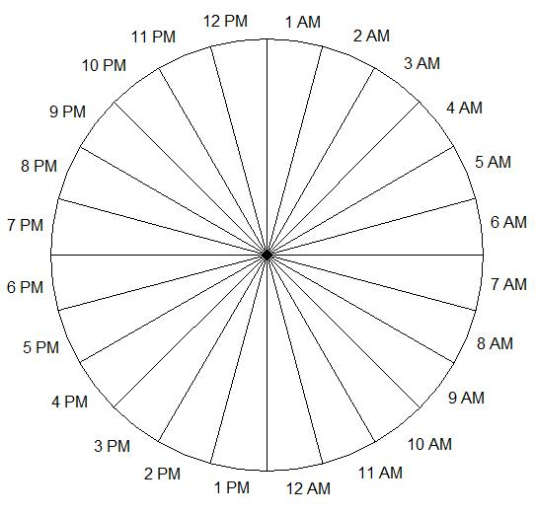
SCHOOL

